Week 6
Module 10

Prb1:
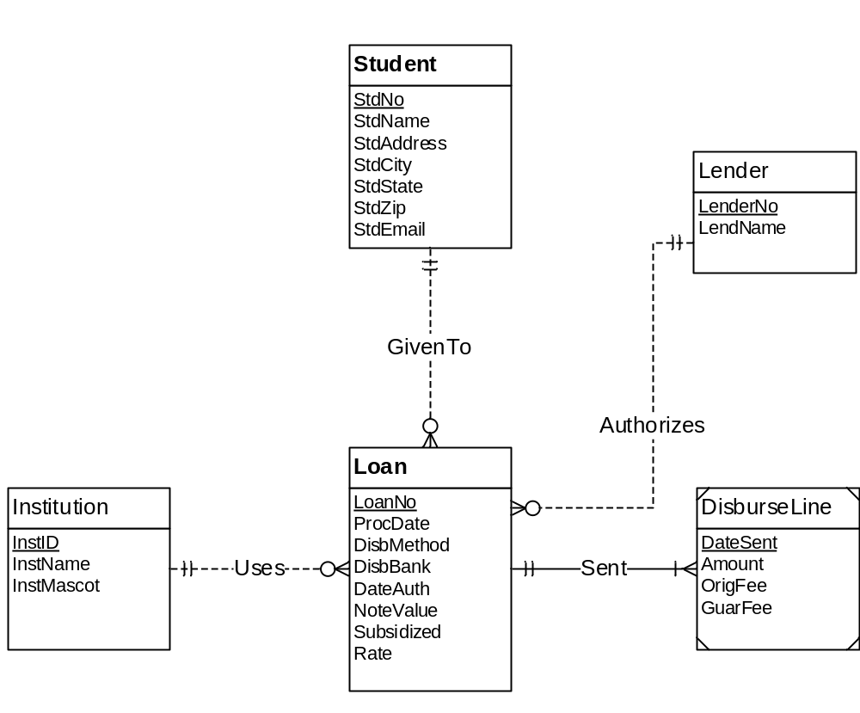

Student (StdNo, StdName, StdAddress, StdCity, StdState, StdZip, StdEmail)
Institution (InstID, InstName, InstMascot)
Loan (LoanNo, ProcDate, DisbMethod, DisbBank, DateAuth, NoteValue, Subsidized, Rate)
Lender (LenderNo, LendName)
DisburseLine (DateSent, Amount, OriFee, GuarFee)

